Nutley Edge Activity Break COVID-19 Risk Assessment
 | Due to the COVID-19 outbreak there will be some changes at Nutley Edge

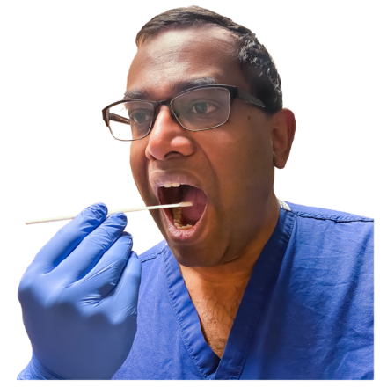 | Where possible all guests and staff are to get a COVID-19 test before going to Nutley Edge

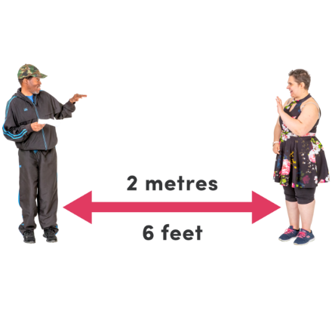 | We will ask our guests to try and maintain social distancing

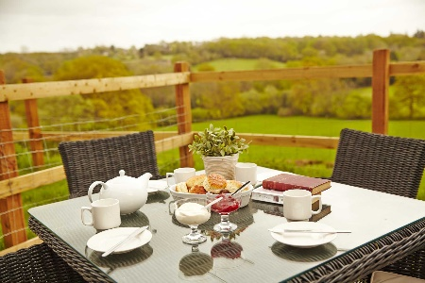 | If the weather permits we can eat our meals outside

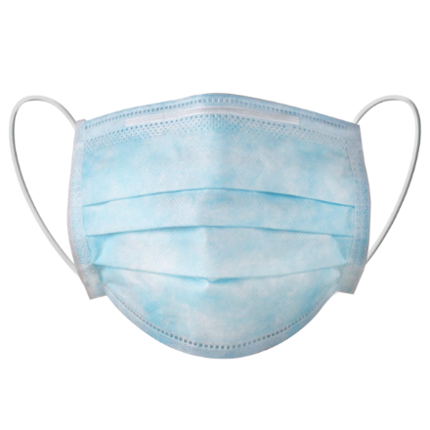 | Where possible all guests and staff are to wear a mask whilst travelling on the minibus

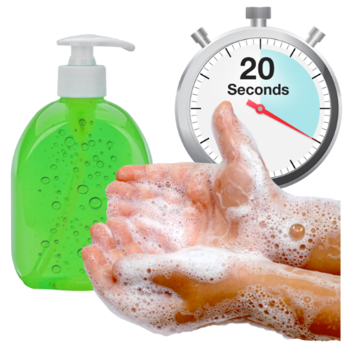 | All guests and staff need to wash their hands regularly for at least 20 seconds

 | Support workers will wear masks, aprons and gloves if you need support with personal care or medication

 | Support workers will need to clean the bathrooms and surfaces regularly each day

