

Board Member

Application Pack

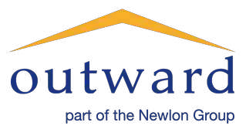
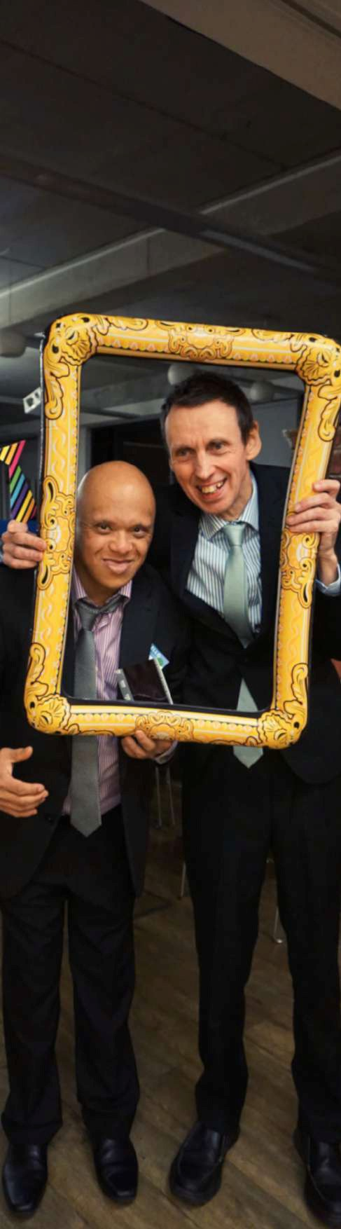CONTENTS

OVERVIEW

1 A Note from the Chair

2 About Newlon

3 About Outward

THE ROLE

4 Join our Board

6 Trustee Role Description

7 Application and Selection

Q u e s t i o n s a b o u t t h e r o l e ?
P l e a s e c o n t a c t
r e c r u i t m e n t @ o u t w a r d . o r g . u k

Dear Applicant,

Thank you for your interest in joining the Newlon Group as a voluntary trustee for our Support and Care charity, Outward. Organisations like ours only thrive through the involvement of highly skilled and knowledgeable people who are willing to give up their time, so I am grateful that you are considering us. I hope the accompanying information will help you to understand us better.

Newlon Housing Trust is a charitable housing association working across North and East London, with a proud record of working on major regeneration programmes, including the award winning Arsenal Regeneration Area in Islington, and more recently, Hale Village in Tottenham.

Outward is within the Newlon Group, employing 450 staff and providing services to approximately 600 vulnerable people. Outward enables people to live independently, providing housing management, care and support to people with learning disabilities, some with complex health and support needs, vulnerable older people, young people who need support, and people on the autism spectrum.

This is an exciting time to join Outward as we are developing a new strategy to take us forward, building on our continued success.

To strengthen our Board, we are looking for people with a real commitment to empowering people who face challenges due to their life circumstances or disability.

After a recent Board skills audit we would particularly welcome candidates with knowledge or experience in analysing financial information, such as management accounts, business planning and taking appropriate mitigating action. An accountancy qualification would be desirable, as would experience of charity or non-profit sector financial management.

If selected, you would join the Outward Board as a Trustee, sharing responsibility with fellow Board Members for setting the strategy and direction of the organisation, managing risk, overseeing growth and financial stability, and assuring the successful delivery of services. There will be lots of opportunity to meet and engage with our residents and services.

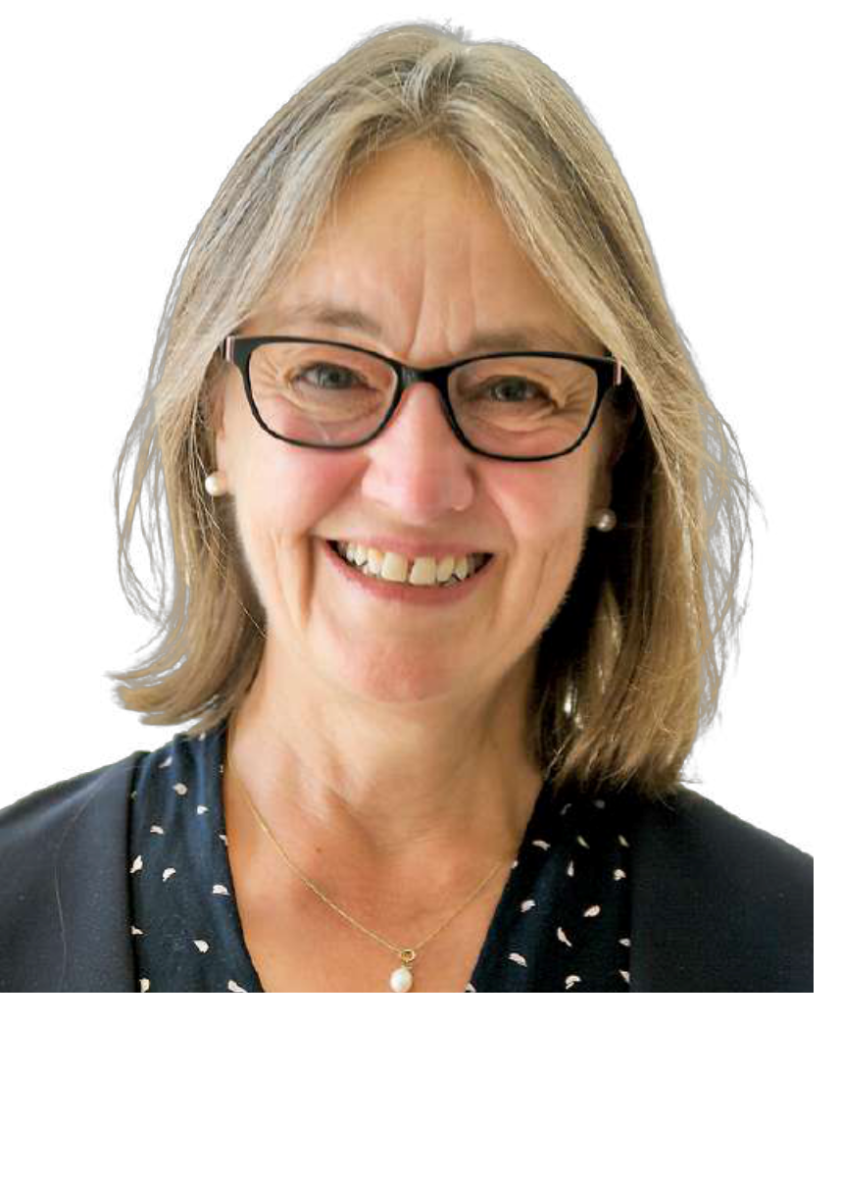If you would like to discuss the role or find out more about our work, please contact Nicky Boland our CEO via email at NBoland@outward.org.uk.

Yours sincerely,

Jane Everton
Newlon Trustee and Chair of Outward

1


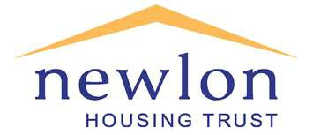The Newlon Group consists of the parent company Newlon Housing Trust and five subsidiaries, Outward, Newlon Fusion, Access Homes, NewlonBuild and NewlonInvest. The Group is not a legal entity in its own right. The term is used to
describe the comprehensive range of high quality community services Group members provide. Group members work together to benefit the communities of north and east London. Joint projects include the award-winning development of Century Court, a state of the art Extra Care scheme in Hackney and the ongoing development of new
housing with adults with learning disabilities.

2
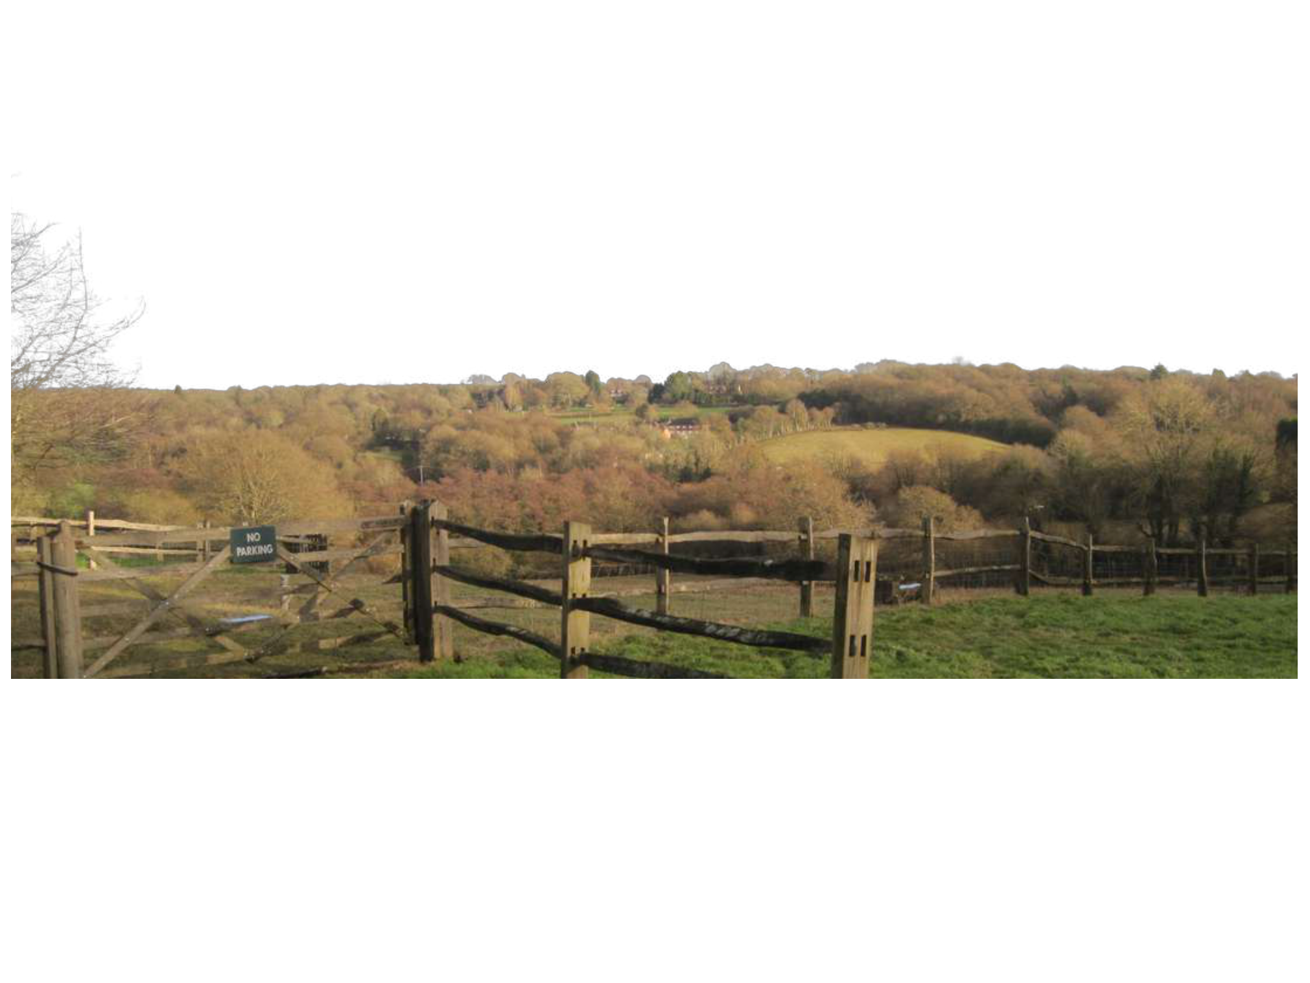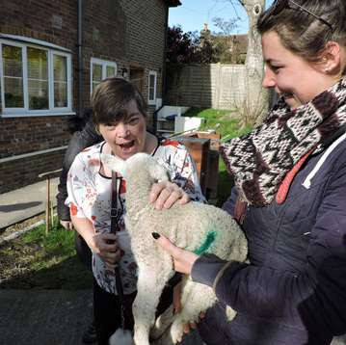

Outward is a successful charitable provider of specialist care and support services ranging from extra care housing for the elderly to individual personalised support packages for people with complex support needs. Outward provides intensive housing management and care and support services to people across north and east London including:
Those with Autism Spectrum Disorders, our services are
Autism Accredited.
Those who have experienced street homelessness, we provide intensive housing management and support.
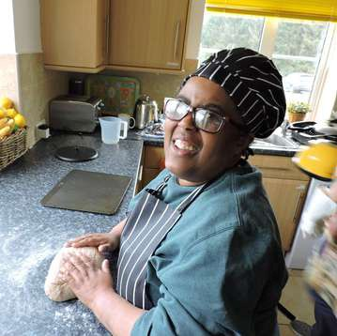Young people in housing need – including those leaving care, providing temporary housing with support to assist them in gaining skills and becoming independent.
Older people who need care and support, floating support, and extra care.
People with learning disabilities, for whom we can provide a range of floating support, personalised services, services for young people coming in transition, supported housing, and registered care.
Respite holidays and activity breaks at Nutley Edge, our specialist holiday centre in East Sussex.

All Outward’s care services are registered as Good with the Care
Quality Commission, and we continue to strive for excellence.

This year, we are working on exciting projects such as delivering our digital transformation, focusing on health and well-being, and working closely with our staff forums on prioritising important issues such as our Equality, Diversity and Inclusion strategy and becoming accredited as a Real Living Wage employer.

3

The Newlon Group is recruiting for new voluntary Board members for Outward, our
Care and Support charity based in London N17.

Since 1976, Outward has been providing innovative housing management, support, and care solutions to people in need. Whether we are providing care and support in partnership with local authorities or supporting people via direct payments, our aim is always for the individual to determine what kind of support we offer. Our focus is on enabling people to have greater choice, independence and control over how they live their lives. As part of the Newlon Group, we manage supported housing for over
600 people and work across 10 London Boroughs. We provide services to a wide range of people, including people with autism and learning disabilities, empowering and enabling people to live
independent lives.

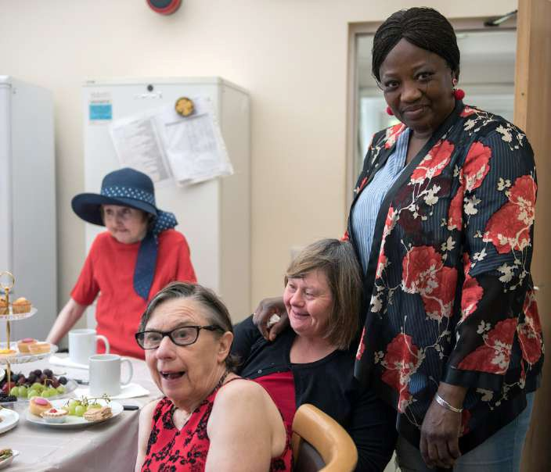We are looking for committed individuals who really want to make a difference in helping people with disabilities to live independently and can demonstrate a clear understanding of the challenges our charity and the people we
support face.

We are keen to recruit Trustees who are genuinely passionate about the positive impact that good social care can make. Perhaps you already have experience as a Trustee and want a new challenge, or perhaps you have relevant skills
and are looking for your first opportunity to join a Board and be involved in a large and successful charity.

Joining a charity board is a great way to contribute to your local community, develop strategic experience, further develop skills and be part of a committed team with common values and goals. It is a fantastic and fascinating way to engage in the charity sector and it’s a role that will give back just as much as you put in and more!

We are committed to ensuring our Board reflects the diversity of the communities we serve and welcome applicants who represent the vastly diverse group of people we support and employ.

This document describes the key responsibilities of trustees and the personal characteristics and behaviours
that go with the role. Please note that all successful candidates will be offered a comprehensive induction, so don’t be deterred if the list appears daunting at first sight.

Trustees must ensure that the organisation:
Complies with its governing document (Memorandum and Articles of Association), its statutory duties, charity law, company law and any other relevant legislation or regulations;
Pursues its charitable objects as defined in the Memorandum and Articles of Association;
Applies its resources exclusively in pursuance of those objects.

Other requirements
Trustees are expected to:
Share the organisation's values and mission to deliver high quality independent living
Contribute actively to the Board of Trustees in giving clear strategic direction to the organisation, agreeing overall policy, defining goals and evaluating performance against targets;
Use their skills, knowledge and experience to help the Board reach sound decisions. This may involve giving special scrutiny to Board papers, leading discussions, focusing on key issues and providing advice and guidance;
Attend and contribute to Board and committee meetings. Trustees are also expected to take part in an annual strategic planning workshop and to pay occasional visits to organisational projects.
Safeguard and enhance the reputation of the organisation;
Ensure the effective and efficient management of the organisation through delegation to the Chief Officer and management team;
Ensure the financial stability of the organisation through continual assessment and performance measurement;
Protect and manage the assets of the charity (property, financial reserves etc.) and ensure the effective use of the charity’s funds;
Be responsible for monitoring the organisation against key performance targets.

Person specification
Trustees are expected to demonstrate the following behaviours, characteristics and abilities: Commitment to the organisation aims in delivering independent living and its values;
Ability to act as an ambassador for the organisation and champion its mission and services;
Willingness to devote the necessary time and effort to the business of the Board and to learn about the organisation, its staff and the people it serves;
Independent judgement, and the ability to challenge appropriately as a ‘critical friend’; Ability to analyse documents and provide informed feedback;
Strategic thinking, creativity and vision geared to enhancing the development and prosperity of the organisation;
Ability to work effectively as a member of a team in order to reach constructive decisions. This includes being able to speak openly in discussion while respecting and taking account of others’ views; Willingness to understand and assume the legal duties, responsibilities and liabilities of trusteeship Application of Nolan’s seven principles of public life: selflessness, integrity, objectivity, accountability, openness, honesty and leadership.

Summary timetable
Interviews will be arranged according to applicants’ availability.

Successful candidates will then be asked to attend and observe the next Board meeting. Following this their appointments will be confirmed by the Group Board.

Skills based selection
We use a skills based approach to the recruitment and selection of Board Members and staff which are the transferable behaviours that we believe will underpin successful performance as a Board Member. They are outlined in the Board Member Role Profile which is part of this pack. The recruitment panel will use the skills and experience set out in the role profile to short-list candidates.

Making your application
Please submit a CV to cover your experience and qualifications and a statement outlining why you want to be a trustee for Outward and the skills and experience you can bring.

recruitment@outward.org.uk

Outward Recruitment
Newlon House
4 Daneland Walk Hale Village London
N17 9FE

Interview
Interviews will take place at Newlon House or potentially via Zoom. A panel consisting of current Board Members including the Chair and the Chief Executive will meet with shortlisted candidates on an individual basis to ask further questions about skills and experience and to answer questions or queries from candidates. Candidates will also be interviewed by a panel of people we support/experts by experience.

